import numpy as np
import pandas as pd
import matplotlib.pyplot as plt
import seaborn as sns
from sklearn.datasets import fetch_openml
from sklearn.model_selection import train_test_split
from sklearn.preprocessing import StandardScaler
from sklearn.metrics import accuracy_score, recall_score

from sklearn. linear_model import LogisticRegression
from sklearn. tree import DecisionTreeClassifier
from sklearn.svm import LinearSVC
from sklearn.naive_bayes import GaussianNB
from sklearn.ensemble import RandomForestClassifier
from imblearn.over_sampling import SMOTE

import tensorflow as tf
from tensorflow.keras.models import Sequential
from tensorflow.keras. layers import Dense, Dropout
df = credit_data. frame
print(f"data shape (Rows, Columns): {df. shape}")
print("Download the datasets from internet")
df.head()

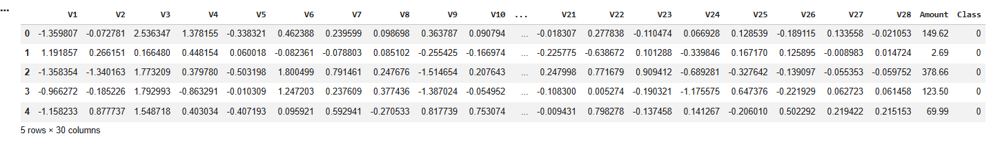
df['Class'] = df['Class'].astype(int)
print("Class distribution in data:\n", df['Class'].value_counts())

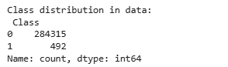
X = df.drop('Class', axis=1)
y = df['Class']

X_train, X_test, y_train, y_test = train_test_split(X, y, test_size=0.2, random_state=42, stratify=y)

scaler = StandardScaler()
X_train_scaled = scaler.fit_transform(X_train)
X_test_scaled = scaler.transform(X_test)

print("\n --- SMOTE ... --- ")
smote = SMOTE(random_state=42)
X_train_smote, y_train_smote = smote.fit_resample(X_train_scaled, y_train)
print(" after SMOT size of data:", pd.Series(y_train_smote).value_counts())

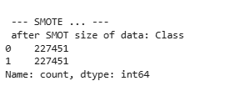
real_model_names = []
real_accuracy_scores = []
real_recall_scores = []

ml_models = {
'Random Forest': RandomForestClassifier(n_estimators=10, random_state=42, n_jobs =- 1),
'Logistic Regression': LogisticRegression(max_iter=500, random_state=42),
'Decision Tree': DecisionTreeClassifier(random_state=42),
'SVM': LinearSVC(random_state=42, dual=False, max_iter=2000),
'Naive Bayes': GaussianNB()
}

print("\n --- 3. Training of machine learnings models ... --- ")
for name, model in ml_models.items():
print(f" Training: {name} ... ")
model. fit(X_train_smote, y_train_smote)
y_pred = model.predict(X_test_scaled)

real_model_names.append(name)
real_accuracy_scores.append(accuracy_score(y_test, y_pred) * 100)
real_recall_scores.append(recall_score(y_test, y_pred) * 100)
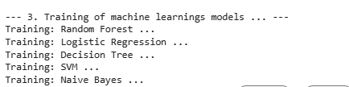
print("\n --- 4. (Neural Networ) Training ... --- ")
ann_real = Sequential([
Dense(32, activation='relu', input_shape=(X_train_smote.shape[1],)),
Dropout(0.2),
Dense(16, activation='relu'),
Dense(1, activation='sigmoid')
])
ann_real.compile(optimizer='adam', loss='binary_crossentropy', metrics=['accuracy'])
ann_real. fit(X_train_smote, y_train_smote, epochs=5, batch_size=128, verbose=0)

ann_prob = ann_real.predict(X_test_scaled).flatten()
y_pred_ann = np.where(ann_prob > 0.5, 1, 0)

real_model_names.append('Neural Network')
real_accuracy_scores.append(accuracy_score(y_test, y_pred_ann) * 100)
real_recall_scores.append(recall_score(y_test, y_pred_ann) * 100)

print("\n --- models graph ... --- ")
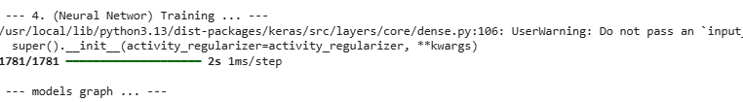
df_real_compare = pd.DataFrame({
'Model': real_model_names * 2,
'Percentage (%)': real_accuracy_scores + real_recall_scores,
'Metric': ['Accuracy'] * len(real_model_names) + ['Recall (Fraud Rate)'] * len(real_model_names)
})
plt.figure(figsize=(14, 7))
ax = sns.barplot(data=df_real_compare, x='Model', y='Percentage (%)', hue='Metric', palette='Set2')

for p in ax.patches:
if p.get_height() > 0:
ax.annotate(f"{p.get_height():1f}%",
(p.get_x()+p.get_width()/2.,p.get_height()),
ha='center', va='center',
xytext=(0, 8),
textcoords='offset points',
fontsize=10, fontweight='bold')

plt.title('Final performance', fontsize=16, fontweight='bold')
plt.xlabel('ML and DL Algo', fontsize=12)
plt.ylabel('percentage (%)', fontsize=12)
plt.ylim(0, 115)
plt.legend(title='Metrics')
plt.tight_layout()
plt.show()

